

SUPERIOR UNIVERSITY LAHORE

GOLD CAMPUS

**NAME:** MUHAMMAD MOIZ RAZA

**ROLL NO:** SU92-BSAIM-F24-**061**

**PROGRAM:** ARTIFICIAL INTELLIGENCE

**SEMESTER:** 3rd SEMESTER

**SECTION:** BSAI-3A

**SUBJECT:** ARTIFICIAL INTELLIGENCE

**Submission Title:** LAB TASK-3

* Model-Based Reflex Agent for Smart Temperature Control

**Submitted To: Sir RASHIK ALI**

**LAB TASK-3**

**TASK:** Model-Based Reflex Agent for Smart Temperature Control

### ****Why we write this code?****

This code is written to simulate a **model-based reflex agent** that works like a smart temperature control system. The purpose is to demonstrate how an agent can make intelligent decisions by considering both the current environment (temperature) and its past actions. Instead of switching the heater on and off unnecessarily, it remembers the last state, which makes it more efficient and realistic. It also stores all actions in a history file for future reference. In short, the code helps us understand how artificial intelligence agents can manage real-world problems such as heating and cooling systems.

## **How the Code Works**

The code starts by initializing the agent with a desired temperature, memory of past actions, and a file for storing history. When a new temperature is given, the act() function decides whether to turn the heater on, off, or keep it unchanged based on conditions. If the temperature is extremely low, the system shuts down completely. If it gets too hot, the fan is automatically turned on. Every decision is stored in both the agent’s memory and a text file. Finally, the show_history() function allows us to see all the decisions taken over time, showing how the agent behaved at different temperatures.

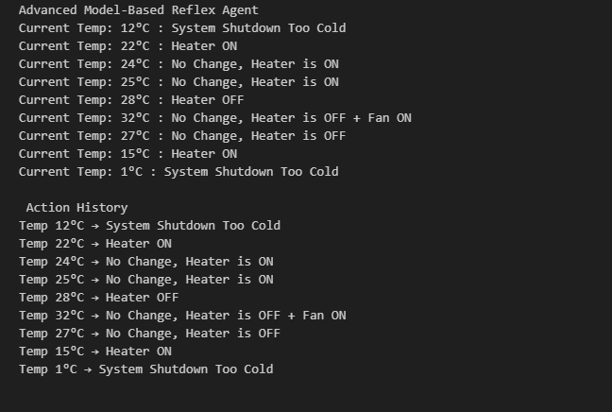**OUTPUTS:**

THE END